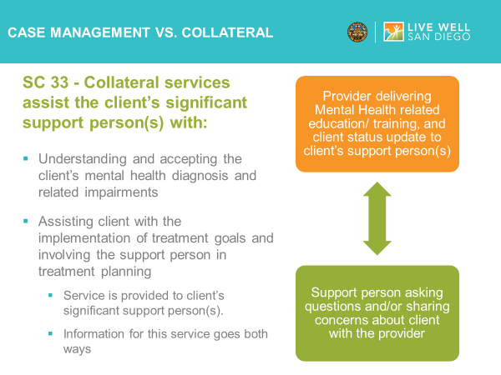

Collateral services include educating and/or training of the significant support person(s) to assist client in meeting their client plan goals and/or in understanding the client's serious mental health diagnosis:
- The intent of collateral services is to educate the significant support person(s) on the client's mental health diagnosis, and related impairments, so that they can support the client in meeting their client plan goals.
- Collateral services help the significant support person to understand and accept the client's condition and involve them in treatment service planning and in the implementation of the client plan.
- A key element is that the support person can work with the client around the client plan goals as a result of the collateral contact.
- The service is provided to significant support person(s).
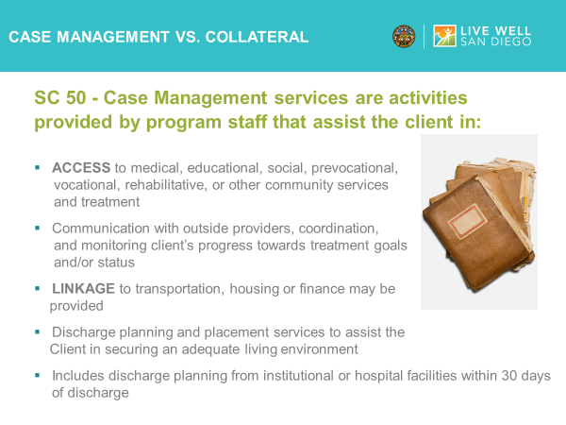
Case management services are activities provided by program staff that assist the client with:
- Access medical, educational, social, prevocational, vocational, rehabilitative, or other community services and treatment.
- Interagency communication, coordination, and monitoring regarding appointments and forms.
- Linkage to transportation, housing or finance may be provided.
- Discharge planning and placement services to assist the client in securing an adequate living environment.
- Includes D/C planning from institutional or hospital facilities within 30 days of the date of discharge.
TITLE 9 CALIFORNIA CODE OF REGULATIONS, SECTION 1810.249
Case Management services provided to assist the client to access needed housing, medical, educational, social, prevocational, vocational, rehabilitative, alcohol, or drug treatment, or other needed community services. Includes targeted case management services of monitoring the beneficiary’s progress toward client plan goals and placement services.

